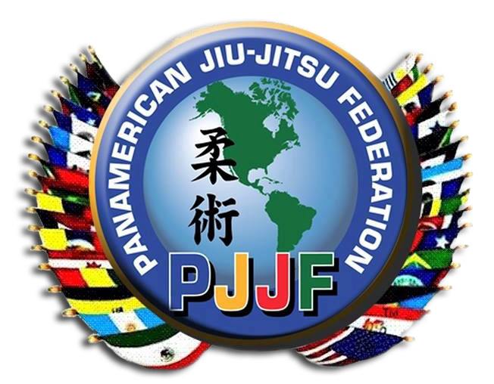

NATIONAL ORGANIZATION MEMBERSHIP APPLICATION

Application Date:

Organization Name:

President:

Address:

Telephone: Mobile telephone:

Email: Fax:

Vice President:

Address:

Telephone: Mobile telephone:

Email: Fax:

General Secretary:

Address:

Telephone: Mobile telephone:

Email: Fax:
1(4)

Treasurer:

Address:

Telephone: Mobile telephone:

Email: Fax:

National Office Address:

Telephone:

Email: Fax:

Official Website:

Organization’s legal status:

Date of foundation of the Organization:

Date of adoption of its Constitution:

Official language of the Organization:

Name & Address of other Executive Committee Members: (Other than the above mentioned Officers)

Name:

Title:

Address:

Telephone:

Email:

Additional information:

Is your Organization a member of other International Organizations?

YES or NO

If yes, Please provide list organizations’ names:

a.

b.

c.

Is Your Organization an independent Group?

YES or NO

Is your Organization part of a Larger National Martial Art(s) Organization?

YES or NO

If yes, what is the name of the larger group?

Please provide the following further information:

Total number of members:

(Provide breakdown)

Male members:

Female members:

Youth members:

Number of affiliated clubs:

Does your organization conduct training camps, seminars or national competitions?

YES or NO

If competitions, what rules do you follow?

Please provide a copy of the rules with your application.

Does your organization have a national rank system?

YES or NO

If yes, please provide a copy.

Does your organization provide national rank certification to your members?

YES or NO

Does your organization have both “minimum time” and “normal time” in grade

requirements?

YES or NO

If yes, please provide details.

Does your organization adhere to any minimum age for dan grades?

YES or NO

If yes, please provide details.

Last Three National Events your organization conducted:

Date of Event & Number of Participants:

1.

2.

3.

Please provide a copy of the following:

1. Constitution or Statutes
2. Administrative Manual (if your organization has one)
3. Complete system curriculum for your training program
4. Short history of your organization’s development
5. List of senior jujitsu black belts (5th degree & above)

Possible additional remarks:

Submitted by:

Title:

Date:

